

Department of Computer Science and Engineering

**Project: Cybot Warrior Cyber Security Robot Car**

**Course Title:** Peripheral & Interfacing Lab

**Course Code**: CSE- 316

**Submission Date:** 19-06-2019

**Submitted To:**

Abdullah Al Omar

B.Sc. in CSE,

University of Asia pacific.

**Submitted By:**

|  |  |  |
| --- | --- | --- |
| Name : Md Mehedi Hasan | Name: Md All Mamun | Name: Arafat Bin Kashem |
| ID: 16201073 | ID: 16201071 | ID: 16201066 |
| Sec: A2 | Sec: A2 | Sec: A2s |

**Contents**

1. Introduction

2. Features

3. Device, Equipment, Software and Sensors we used full information

4. Circuit Diagrams and Pin Configuration

5. Code

6. Full Project GitHub Repositories Link And Video Instruction

8. Pros and Cons

9. Conclusion

**1.INTRODUCTION:**

Cybot Warrior Cyber Security Robot is a Car model robot which has lots of cyber security features that can be used for ethical hacking and penetration testing purpose and also it is an automatic car.

**2.FEATURES:**

* Automatic Obstacle Avoidance Robot Car with Fastest Speed and High Accuracy
* Automatic and Manual Controlled Robot Accident Avoidance Car with Fastest Speed and High Accuracy
* Bluetooth Controlled by Android Smart Phone
* Wi-Fi Controlled by Wireless Keyboard and Touch Pad
* Wi-Fi Jamming
* Wi-Fi Routing
* Display Support
* Kali Linux Hacking Operating System with Single Board Computing

**3.Device, Equipment, Software and Sensors:**

* Arduino UNO
* Arduino Connecting Cable
* Arduino IDE
* L239D Motor Controller
* 4 Yellow DC Motor
* 4 Yellow Wheel
* 1 Tower Pro Servo Motor
* Ultrasonic SR-04 Sensor
* Bluetooth Module HC-05
* Switch
* Home Made Card Board Chassis
* Jumper Wire or Connecting Wire Set
* 4 Rechargeable LIPO Battery 3.7 Volt
* Battery Charger
* Battery Holder
* 5 Volt Power Bank
* Android Smart Phone
* Raspberry pi 3 b+
* 3.5-inch touch display wave share
* Mini Wireless Keyboard with Touch Pad

**FULL INFORMATION:**

Arduino UNO:

The Arduino Uno is a microcontroller board based on the ATmega328 Microprocessor. It has 14 digital input/output pins (of which 6 can be used as PWM outputs),6 analog inputs, a 16 MHz ceramic resonator, a USB connection, a power jack, an ICSP header, and a reset button.

It contains everything needed to support the microcontroller. simply connect it to a computer with a USB cable or power it with an AC-to-DC adapter or battery to get started. The Uno differs from all preceding boards in that it does not use the FTDI USB-to-serial driver chip.

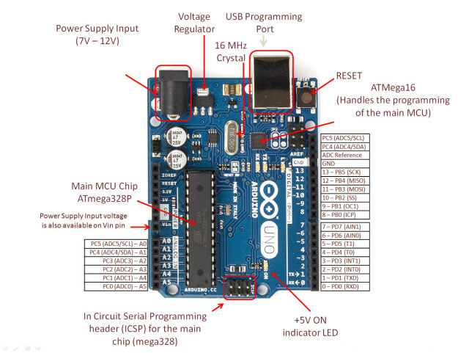

Figure 1: Arduino UNO with Pin Configuration and information

Arduino Uno Connecting Cable:

This is a standard USB 2.0 cable. This is the most common A to B Male/Male type peripheral cable, the kind that's usually used for printers. Compatible with most SFE designed USB boards as well as USB Arduino boards like the Uno. Using this connecting cable can be upload Arduino Uno board also can be use Supply power (5V)

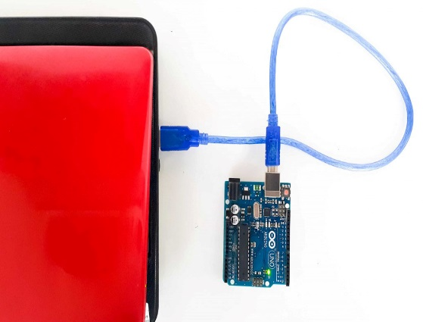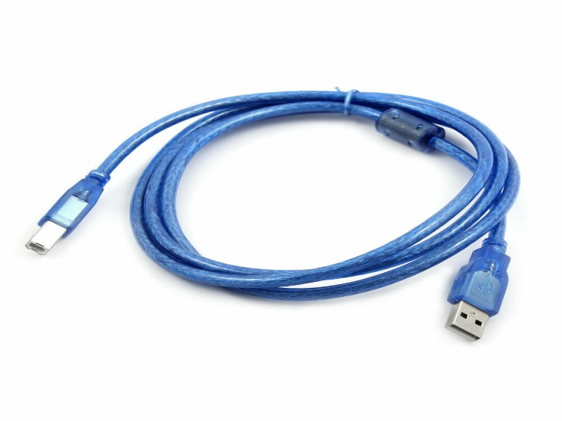

Figure 2: Using Arduino UNO Cable Connect Laptop with Arduino

Arduino IDE:

Arduino IDE is an open source software that is mainly used for writing and compiling the code into the Arduino Module. It is an official Arduino software, making code compilation too easy that even a common person with no prior technical knowledge can get their feet wet with the learning process. It is easily available for operating systems like MAC, Windows, Linux and runs on the Java Platform that comes with inbuilt functions and commands that play a vital role for debugging, editing and compiling the code in the environment.

Arduino IDE Windows Download : <https://www.arduino.cc/download_handler.php?f=/arduino-1.8.9-windows.exe>

Arduino IDE Linux Download : <https://www.arduino.cc/download_handler.php?f=/arduino-1.8.9-linux64.tar.xz>

Arduino IDE MAC OS X Download : <https://www.arduino.cc/download_handler.php?f=/arduino-1.8.9-linux64.tar.xz>

Arduino IDE Example:

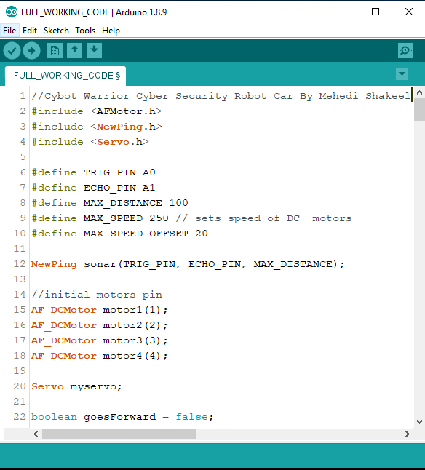

Figure 3: Arduino Ide Example

L239D Motor Controller:

L293D is a dual H-bridge motor driver integrated circuit (IC). Motor drivers act as current amplifiers since they take a low-current control signal and provide a higher-current signal. This higher current signal is used to drive the motors.

L293D contains two inbuilt H-bridge driver circuits. In its common mode of operation, two DC motors can be driven simultaneously, both in forward and reverse direction. The motor operations of two motors can be controlled by input logic at pins 2 & 7 and 10 & 15. Input logic 00 or 11 will stop the corresponding motor. Logic 01 and 10 will rotate it in clockwise and anticlockwise directions, respectively.

Enable pins 1 and 9 (corresponding to the two motors) must be high for motors to start operating. When an enable input is high, the associated driver gets enabled. As a result, the outputs become active and work in phase with their inputs. Similarly, when the enable input is low, that driver is disabled, and their outputs are off and in the high-impedance state.

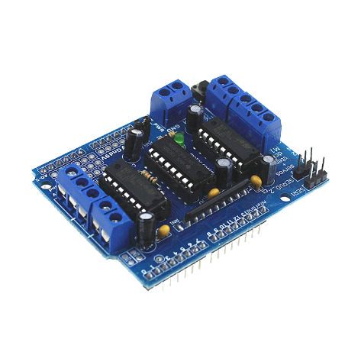

Figure 4: L293D Motor Driver

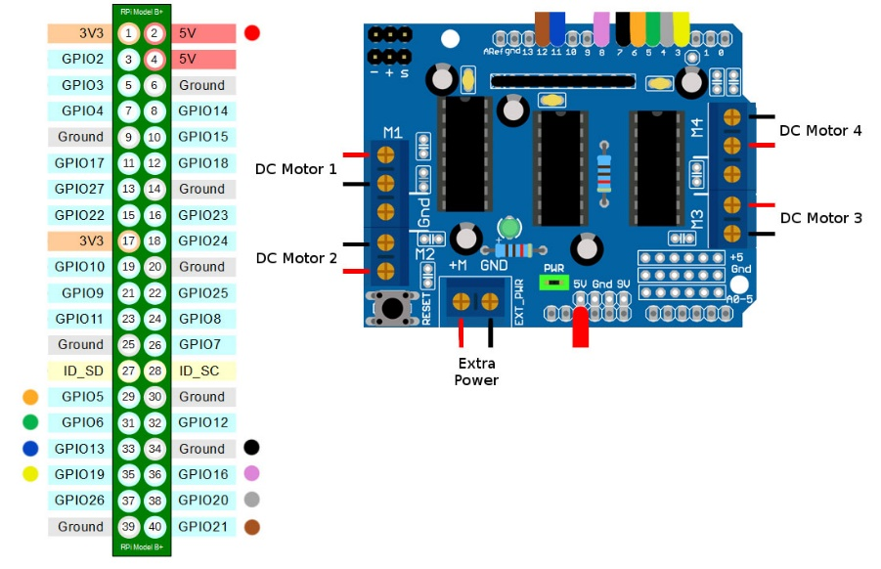

Figure 5: L293D Motor Driver Pin Configuration

Yellow DC Motor & Wheel:

DC gear motor and wheel set for making robots! These motors are light weight, high torque and low RPM. They can climb hills and have excellent traction, plus you can mount the wheel on either side of the motor with its double-sided output shaft. The 6V, 83rpm Micro Yellow DC Motor with Back Shaft is ideal for DIY enthusiasts. This motor is inexpensive, small, easy to install, and ideally suited for use in a mobile robot car. We recommend this L2398 Motor shield to driver this motor. There is a wheel set in here.

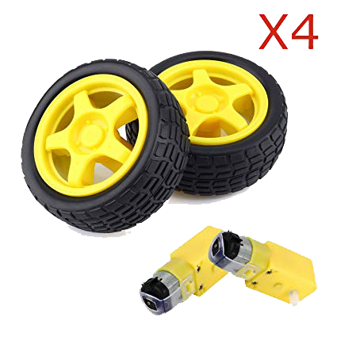

Figure 6: Yellow DC Motor and Wheel

Specifications:

* Motor Voltage: 3 – 12 V
* Motor Current: 70 mA (typical) – 250 mA (max)
* Speed: up to 170 RPM
* Torque: up to 0.8 Kg
* Gear Ration: 1:48
* Wheel Diameter: 66 mm
* Wheel Width: 27 mm
* No-load speed(3V): 50RPM
* No-load speed(5V): 83RPM
* Torque (3V): 0.8Kgcm
* Torque (5V): 1.0Kgcm
* Size: 69mm * 37mm * 23mm
* Weight:30g

Tower Pro Servo Motor:

Servo Motor is tiny and lightweight with high output power motor. Servo can rotate approximately 180 degrees (90 in each direction), and works just like the standard kinds but smaller. You can use any servo code, hardware or library to control these servos. Good for beginners who want to make stuff move without building a motor controller with feedback & gear box, especially since it will fit in small places. It comes with a 3 horns (arms) and hardware.

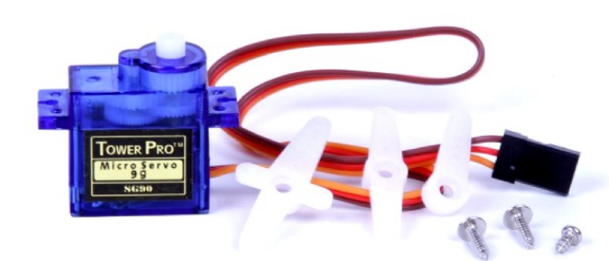

Figure 7: Tower Pro Servo Motor

Tower Pro Servo Connection Diagram:

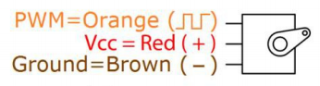

Figure 8: Servo Motor Connection

* PWM connect with any PWM GPIO Pin
* VCC Connect With 5-volt GPIO Pin
* Ground/GND Connect with any GPIO GND Pin

Ultrasonic HC-SR04:

HC-SR04 Ultrasonic (US) sensor is a 4-pin module, whose pin names are Vcc, Trigger, Echo and Ground respectively. This sensor is a very popular sensor used in many applications where measuring distance or sensing objects are required. The module has two eyes like projects in the front which forms the Ultrasonic transmitter and Receiver. The sensor works with the simple high school formula that

Distance = Speed × Time

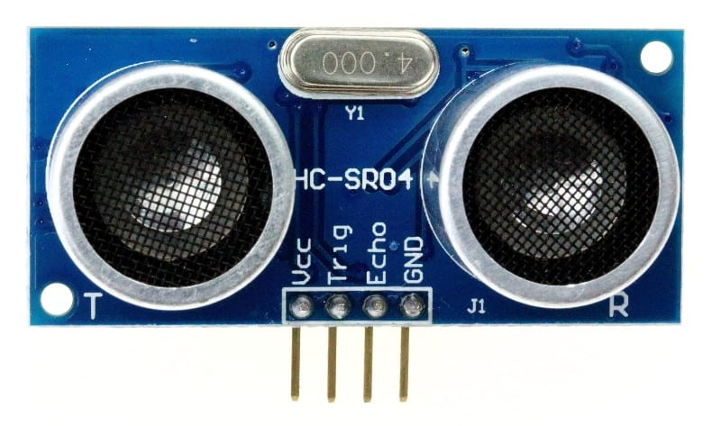

Figure 9: Ultrasonic HC-SR04 Sensor

The Ultrasonic transmitter transmits an ultrasonic wave, this wave travels in air and when it gets objected by any material it gets reflected back toward the sensor this reflected wave is observed by the Ultrasonic receiver module as shown in the picture below

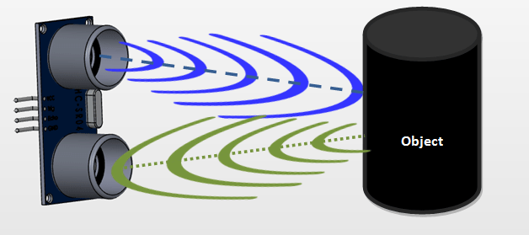

Figure 10: Ultrasonic Sensor Working Principle

Bluetooth Module HC-05:

The HC-05 Bluetooth Module is a very cool module which can add two-way (full-duplex) wireless functionality to your projects. You can use this module to communicate between two microcontrollers like Arduino or communicate with any device with Bluetooth functionality like a Phone or Laptop. There are many android applications that are already available which makes this process a lot easier. The module communicates with the help of USART at 9600 baud rates hence it is easy to interface with any microcontroller that supports USART. We can also configure the default values of the module by using the command mode. So, if you looking for a Wireless module that could transfer data from your computer or mobile phone to microcontroller or vice versa then this module might be the right choice for you. However, do not expect this module to transfer multimedia like photos or songs; you might have to look into the CSR8645 module for that.

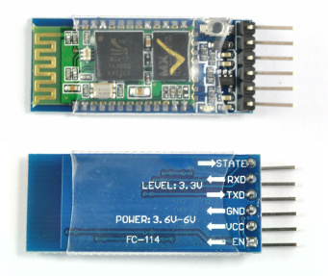

Figure 11: HC-05 Bluetooth Module

Pin Diagram of HC-05 Bluetooth Module:

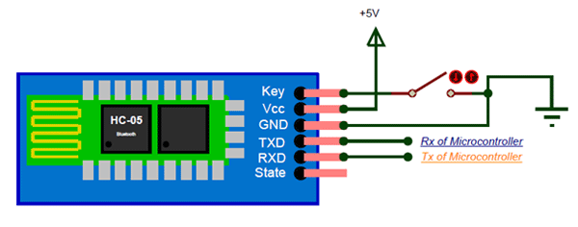

Figure 11: HC-05 Bluetooth Module Pin Diagram

Switch:

Its use for controlling power ON/OFF supply from battery or power source to Arduino boards

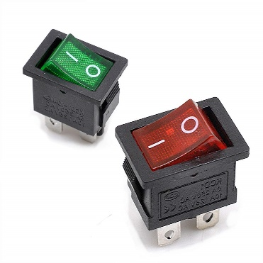

Figure 12: Switch

Home Made Car Chassis:

Using Card board we can make a base of our robot car where all the equipment and sensors will be attached. Also, we can buy readymade chassis from shop

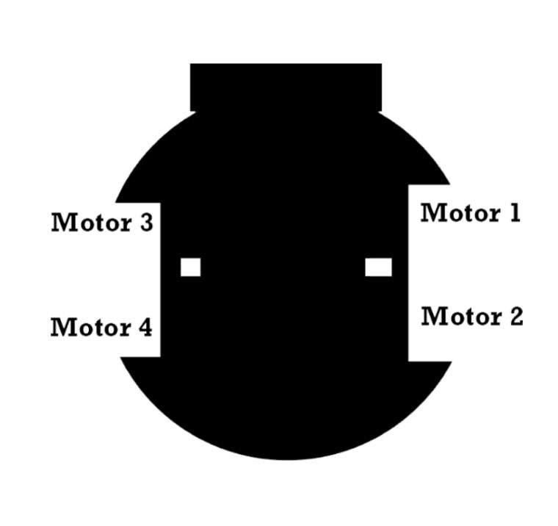

Figure 13: Home Made Robot Car Chassis

Jumper Wire or Connecting Wire Set:

A jump wire is an electrical wire, or group of them in a cable, with a connector or pin at each end, which is normally used to interconnect the components of a breadboard or other prototype or test circuit, internally or with other equipment or components, without soldering.

It’s uses to build the circuit or connection between Arduino boards and other sensors to communicate with each hardware equipment

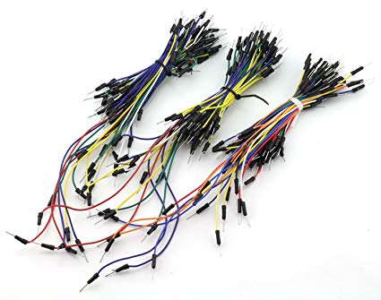

Figure 13: Jumper wire

Rechargeable LIPO Battery 3.7 Volt or Power Bank:

Rechargeable LIPO battery is the best way to give power supply to any kinds of electronics hardware Arduino projects or robotics projects because this is rechargeable so that it can re-use.

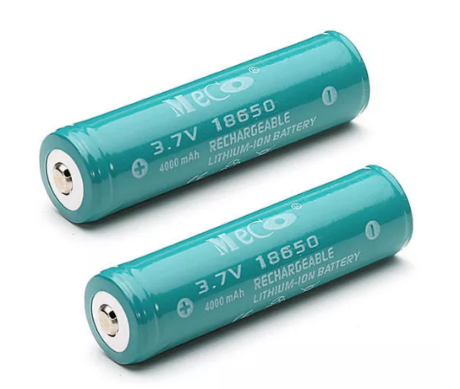

Figure 14: Rechargeable LIPO Battery

Battery Charger:

For Recharging this lipo battery, we need a special battery charger. During the project making it can be discharge so we need this special battery charger below

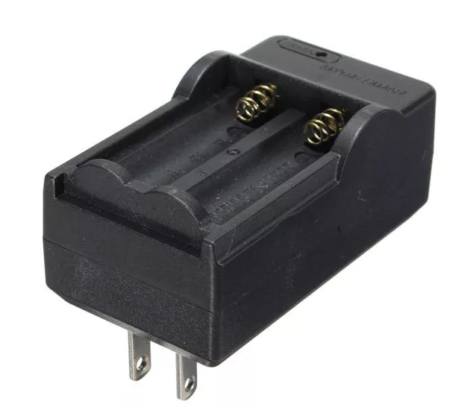

Figure 15: Lipo Battery Charger

Battery Holder:

To attached the battery, we need a battery holder so that we can easily add those battery to our robot car chassis.

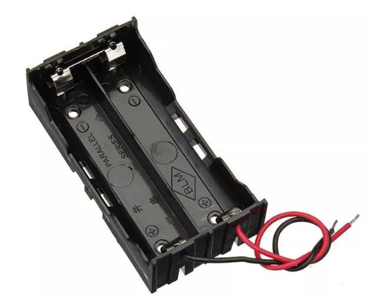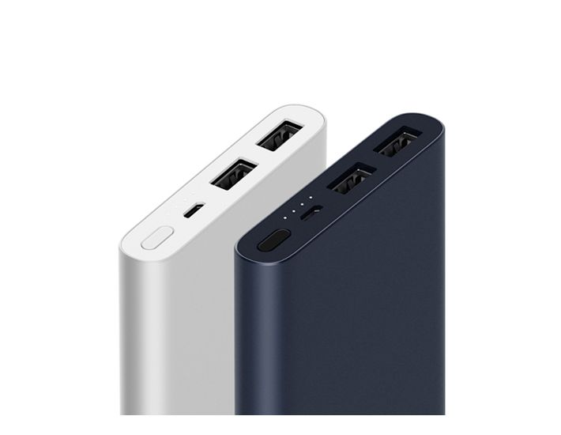

Figure 16: Lipo Battery Holder and Power bank

Also, battery holder can protect the battery from outside damages like heat. Also, we can use power bank as a power supply but I prefer to use separate power source for different parts of your project. It will help us to give recommended power supply to our projects and make it faster to work.

Android Smart Phone:

There are lots of android apps are available on play store to control Arduino based robotics project using Bluetooth or Wi-Fi module to get connected with your robotics projects we need to choose app according to our project here is the app I use to control my robot below

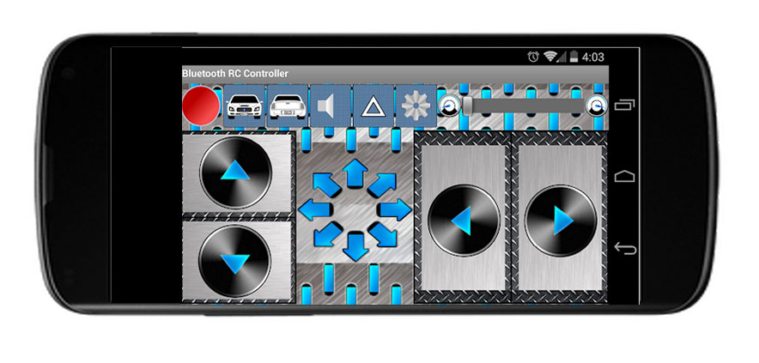

Mobile App Link : <https://play.google.com/store/apps/details?id=braulio.calle.bluetoothRCcontroller>

Raspberry pi 3 b+:

The Raspberry Pi is a low cost, credit-card sized computer that plugs into a computer monitor or TV, and uses a standard keyboard and mouse. We use raspberry pi 3 b+ to run Kali Linux Hacking Operating system on it to add almost all cyber security features.

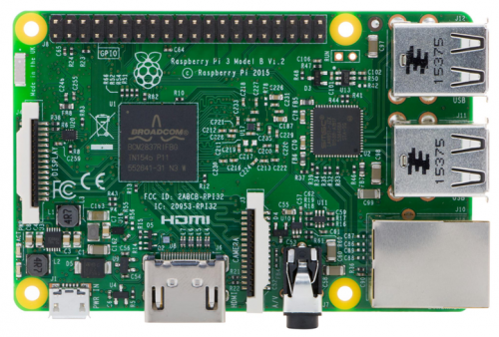

Kali Linux OS Img for Raspberry Pi Download Link : <https://images.offensive-security.com/arm-images/kali-linux-2019.2-rpi3-nexmon-64.img.xz>

3.5-inch Touch Display:

We use 3.5-inch tft touch screen display to raspberry pi as a monitor or screen of our kali Linux operating system. So that we can see what is happening in our kali Linux attacks and the outputs. We can use it as a WIFI jammer, WIFI router and different types of cyber security attacks.

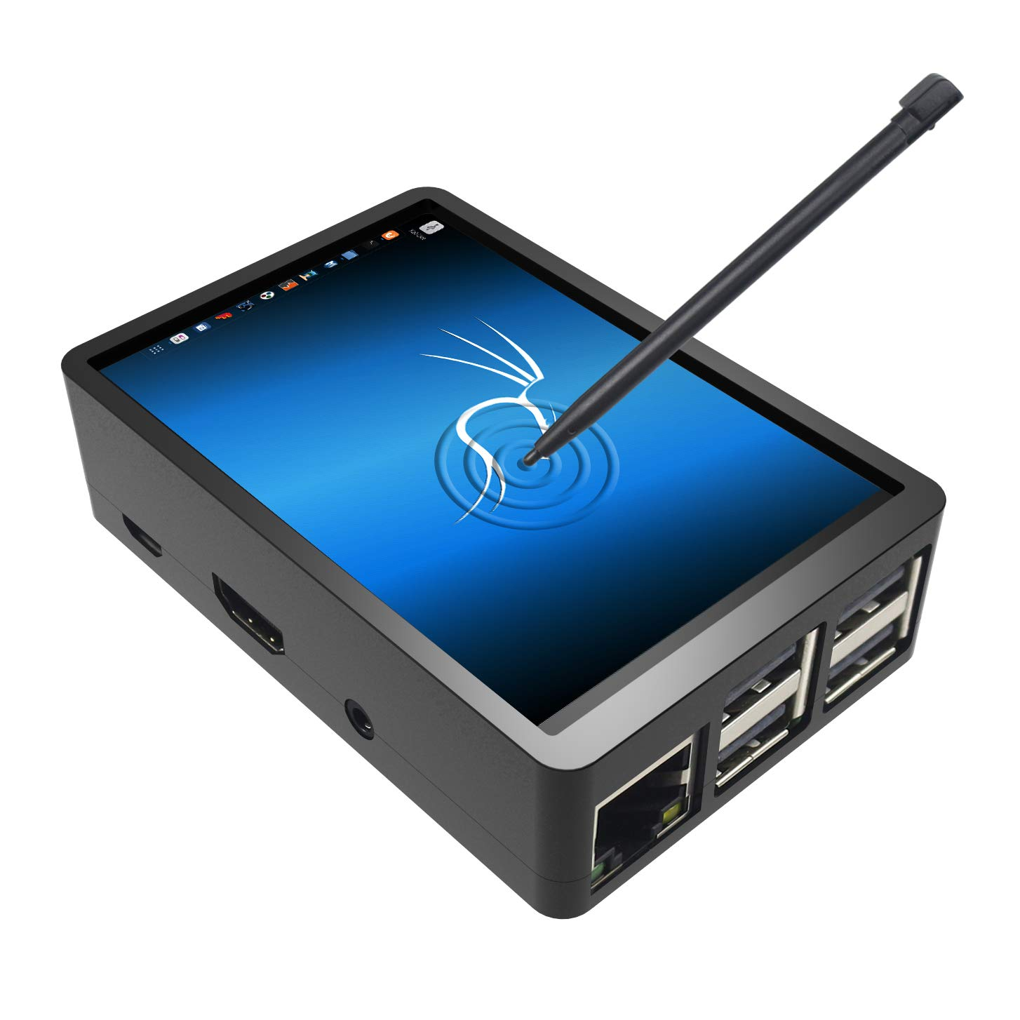

Mini Wireless Keyboard with Touch Pad:

This mini wireless keyboard with touch pad helps us to control and use our kali Linux operating system as like a single board computer.

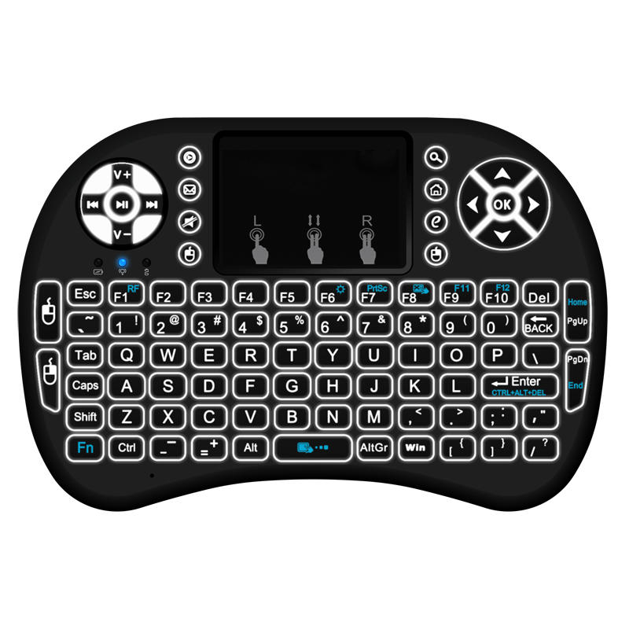

**Circuit Diagrams to Build the Robot Car Body with All the Equipment’s:**

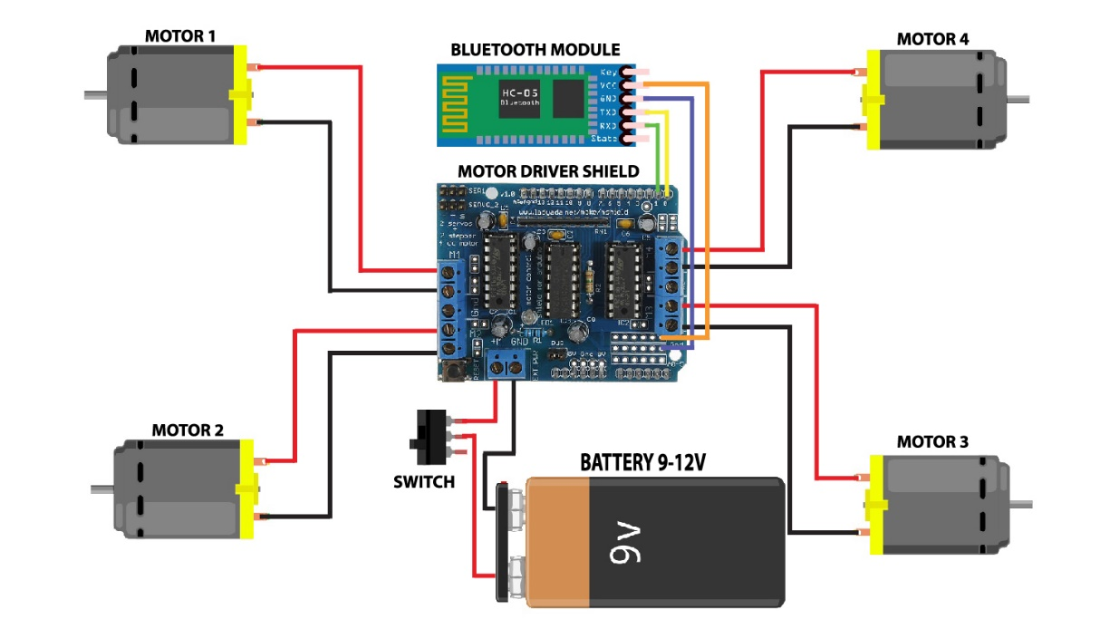

Steps:

* Attach the L239d Motor controller using the gpio pins of Arduino board it fit well on Arduino board we do not need any kind of connecting wire or soldering,
* Connect 4x DC Motor two the motor controller M1, M2, M3 & M4
* Connect the lipo battery to the motor controller power in ports with a switch
* Connect the HC-05 Bluetooth Module two the Arduino gpio pin TX & RX using soldering.
* Two give power to the Bluetooth module we have to use +5 volt from motor driver GPIO pins and GND Pins
* Then Connect The servomotor with the motor driver shield servo connector section
* After that attached the ultrasonic sensor with the servo robot using ultrasonic sensor holder with glue.
* Now attached all the equipment on your home-made chassis according to your design.
* Then install kali Linux arm images on a SD card and insert it to raspberry pi and attached it to the robot chassis and using the power bank give power to the raspberry pi.
* Then connect the wireless receiver to the usb port of raspberry pi and power on the mini wireless keyboard with touchpad using the wireless connection.
* Full Video Instruction on YouTube : <https://www.youtube.com/watch?v=DINk1eWiKu8&list=PLoAx5AQlvczW3r1IadJF2QM48WNyI54Rw>
* Full Project Github Repositories : <https://github.com/mehedishakeel/CyBot-Warrior---DIY-Robot-Cyber-Security-Warrior-By-Mehedi-Shakeel---SSTECTUTORIALS>

**Arduino Code for CYbot Warrior Robot :**